MANCETTER PARISH COUNCIL

You are invited to the Parish Council Meeting of the Parish of Mancetter,
to be held in the schoolroom of St Peter’s Church Mancetter
on Tuesday 25th January 2022 at 7pm prompt.

Can members of the public please confirm attendance with the Clerk prior to the meeting by emailing parishclerk@mancetter.org.uk or telephoning 07368 265051 so that COVID 19 risk assessment guidance can be explained.

AGENDA

- Welcome and Coronavirus Risk Assessment.

- Apologies.

- Chairman’s request that anyone recording the meeting make themselves known.

- Notice of Interest.

- Public Question time up to 15 Minutes for Members of the Public to raise issues.
It is still advised that queries or concerns are raised with the clerk prior to the meeting, in order to minimise the time spent within the building.

- Minutes of the last meeting:

- To accept the draft minutes of the Parish Council Meeting held on 23rd November 2021.

- Matters Arising from the Parish Council Meeting on 23rd November 2021.

  - Brief updates on the December Quarry Liaison Meeting, Traffic and Speed surveys, Community Speed Watch and Village Signs.

- Reports from the Police, County and Borough Councillors.

- Finance

- Signing of all payments since the last meeting in accordance with the Bank mandate.

- To consider the introduction of a Scribe Accounting System at a fully supported cost of £25.00 per month to minimise the workload for Audit, produce VAT reports for reclaim, and safeguard financial records from the risk of incorrect spreadsheet formulas as recommended by WALC.

- To finalise and agree the 2022/2023 Parish Council budget.

- To discuss the options and authorise the precept request to be submitted to NWBC by 31st January 2022 including the report for Mancetter Matters and the Website.

- To review the Allotment Rents for the forthcoming year and authorise the Chairman to collect payments and review the waiting list in conjunction with the Clerk.

- To consider from April a payment request of an additional £25.00 per quarter to the Rights of Way Contractor to help cover an increase in fuel costs.

- To review the parish council financial reserves for the forthcoming financial year.

- Platinum Jubilee

- Update on the January meeting and progress for the Platinum Jubilee
celebrations within Mancetter and Ridge Lane; including Shield decorating and Tulip planting.

- Meetings and Training

- Feedback from the WALC virtual Local Climate Action Day on 19th January 2022,
including an update on local Climate Change research and community engagement ideas.

- To consider declaring an interest in information provided by the “20 is Plenty” initiative.

- Update on the Rights of Way Training being held on 25th January 2022.

- Planning Matters and New Applications: Update on recent Planning Applications, Enforcement Issues and Determinations from Planning Lists.

Pending Applications

- PAP/2021/0177 – 19 Nuneaton Road Mancetter
- PAP/2021/0607 - 4 Mancetter Road (additional rear extension)
- PAP/2021/0609 - 37 Daniel Road

Applications Determined

- PAP/2021/0545 – Ladywood Farm Ridge Lane – Granted
- PAP/2021/0484 and PAP/2007/ 0730– Fir Tree Paddock Quarry Lane Mancetter - Granted
- PAP/2021/0506 – The Barn Mill Lane Mancetter - Granted

New Applications to be discussed:

- PAP/2021/0675 – 64 Mancetter Road
- PAP/2021/0386 – 86 Mancetter Road
(Both Single Storey Rear Extensions).

13 Cemetery and Maintenance around the Parish.

- To review the environmental suitability of additional tree planting to safeguard the remaining burial spaces in the cemetery extension due to the water table and proximity to the flood plain.

- Update on cemetery railings, marker slabs, memorials and specialist tree planting.

- Tom White Waste Invoices and Waste Disposal documentation.

- Overhanging Yew branches by the driveway to St Peter’s Church Mancetter.

- Date of next meeting-

Tuesday 22nd March 2022

Parish Council Meeting 7pm at St Peter’s Church Mancetter.

Signed

Date 19th January 2022.

Elane Higgins
Parish Clerk Mancetter Memorial Hall Old Farm Road Mancetter CV9 1QN Tel: 01827 722552 Email: parishclerk@mancetter.org.uk
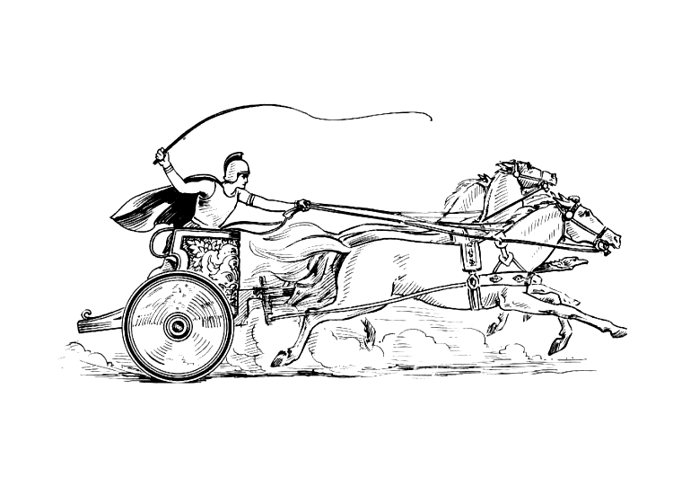

Manduessedum - Mancetter Village
(Place of War Chariots)
Mancetter Parish Council
Serving the People of Mancetter and Ridge Lane

